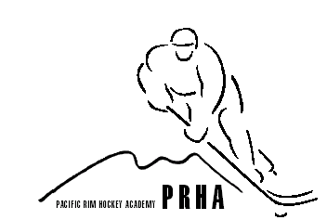 Pacific Rim Hockey Academy Ltd.
Email craig@rpmhockey.com Web www.rpmhockey.com

What are your intentions for the 2021/22 School Year? Please check one
❐ Returning to Academy ❐ Not, returning to Academy ❐ I am not sure at this time

Re-registrations without payment (deposit & post-dated payments) are not accepted.
Deposit of $264 Due Apr 1/21.

Academy Fees 2021/22 - $1320 - RPM will accept 5 payments of $264, as a convenience to parents.
Please note: these are not monthly payments but a payment plan
Academy Payment plan schedule:
Payment 1 Deposit (Due Apr 1/21) $264 (withdraw before May 31/21 – Deposit refunded)
Payment 2-5 Sept 1-Dec 1 $264

I will pay for this academy by: Visa ❐ Master Card ❐ American Express ❐
Card Number _________/__________/__________/____________/ Exp _________/__________CVC(# on back)______
❐Info online from last year

All registrations must be secured with a credit card.

Any withdrawals after Sept 1/21, will be pro-rated based on Administrative approval.
Any withdrawals after the 1st of each month are charged for that month. For ex: withdraw Oct 10, Oct payment is not refundable.

The Deposit is fully refundable up to May 31/21, but a request must be made via email to holly@rpmhockey.com by May 31/21 to obtain a refund.
Should your student withdraw from the academy for any reason you must email Pacific Rim Hockey Academy at holly@rpmhockey.com to be eligible for any refund. Administration is provided by the Pacific Rim Hockey Academy.

I have (Parent/Guardian Name) Please print _____________________________have read the above application & agree to the terms outlined. I understand it is the parent/guardian responsibility to ensure payments are in good-standing and up-to-date & failure to do so could result in restricted participation for my child. I understand that if I choose to withdraw my child, I must email holly@rpmhockey.com to be eligible for a refund.

Parent/Guardian Signature __________________________________Date_____________________________________

Student Name:__________________________Grade for 2021/22 year:____School:__________________________

Re-Registration forms can be emailed to holly@rpmhockey.com

“The pursuit of Academic and Hockey Excellence”

